Apiculture

APICULTURE:
❖ Beekeeping is defined as maintenance of beehives by humans.
❖ Honeybees are considered as important pollinators.
❖
Different species of honeybees
➢ There are four well known species of true honeybees (belonging to genus Apis) in the
world:
1. Rock bee, Apis dorsata
2. Little bee, A. florea
3. Asian bee, A. cerana
4. European bee, A. mellifera
❖
Characteristics of four well known species of honeybees
Apis dorsata
Apis florae
Nesting
Open nesting.
Builds single large comb
(ca 1m2)
attached to branches of
trees or rocks etc.
Open nesting.
Builds single small comb
(ca size of palm of hand)
fixed to branches of bushes.
Distribution in India
Found in plains as well
as hills up
to 1600 meters above
sea level.
Highly migratory.
Found in plains up to 300
metres above sea level.
Highly migratory.
Size
Biggest honeybee (16-
18mm)
Smallest Apis bee (9-
10mm)
Average honey yield per
colony/year
500 g
(wild bees; cannot be
domesticated)
Method of Honey
extraction
40 kg
(wild bees; cannot be
domesticated)
By squeezing
(unhygienic)
Number of cells/10cm
comb
(worker cells)
By squeezing
(unhygienic)
18-19
32-36
Apis cerana
Apis mellifera
Nesting
Cavity nesting.
Builds many parallel combs
in cavities of tree trunks,
hollows of rocks, poles and
Cavity nesting and similar
in habits to Apis cerana and
builds parallel combs.
other covered places
Distribution in India
Found throughout India
Exotic bee to India.
Introduced successfully in
1962.
Size
Medium size (14-15mm)
Medium size (14-16mm
Average honey yield per
colony/year
15 kg
Hive bees; can be
domesticated
Method of Honey
extraction
3 kg
(Hive bees; can be
domesticated)
By centrifugal honey
extractor from the hived
bees (hygienic
Number of cells/10cm
comb
(worker cells)
By centrifugal honey
extractor from the hived
bees (hygienic).
21-25
17-19
❖ Like any insect, body of honeybee can be distinguished in to three parts:
1. Head
2. Thorax
3. Abdomen
1. Head
➢ Bears a pair of geniculate antennae.
➢ Mouth parts of worker bees are modified for sucking and lapping.
➢ Inside the head there are long coiled strings of small lobes known as hypopharyngeal
glands which secrete glandular food known as royal jelly that is fed to queen and young
larvae.
➢ Prothoracic legs serve as antenna cleaner.
➢ On Mesothoracic legs, bushy tarsi serve as brushes for cleaning of thorax.
➢ In worker bees, smooth somewhat concave outer surface of hind tibia is fringed with
long curved hairs and forms pollen basket or corbicula.
➢ In workers egg laying apparatus (ovipositor) is modified into sting.
➢ Queen uses ovipositor for egg laying and stinging rival queen.
➢ Digestive system is unique in having oesophagus with expanded honey stomach which
stores the collected nectar.
➢ Sperms are stored in the queen in a sac like structure known as spermatheca. The stored
sperms are utilized by queen throughout her lifetime as she does not go for mating once
starts egg laying.
➢ A normal colony, during active season is composed of 3 kinds of individuals: one queen,
thousands of workers (10000 to 30000 or even more) and few hundreds of drones, which
vary in size. In addition, each colony has different developmental stages viz eggs,
larvae and pupae which are collectively known as brood.
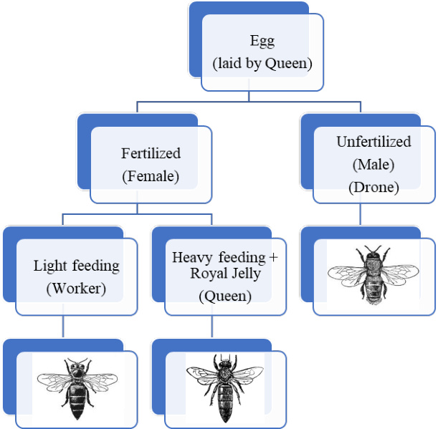

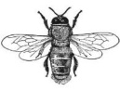

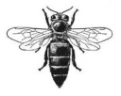

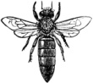

❖
Queen:
➢ Only one queen is found in a colony except under supersedure or swarming instinct.
➢ She is mother of whole colony producing workers and drones and is the only perfectly
developed female member of the colony.
➢ Her function is to lay eggs. She does not have motherly instinct or ability to feed the
brood. She is fed lavishly by a large number of nurse bees with highly nutritious food
known as royal jelly.
➢ A good queen can lay 1500-2000 eggs per day.
➢ A laying queen is the longest bee in the colony.
➢ Fertilized eggs produce workers (also queens) and unfertilized eggs produce drones.
➢ A good, mated queen may work satisfactorily for 2 or more years, although queens can
live eight years or longer.
➢ The virgin queen mates with a number of drones (5-7) within 5-10 days of emergence in
the air (not inside the hive) and spermatozoa are stored in spermathecal. Stored sperms
are utilized to fertilize eggs throughout her life till exhausted.
❖
Worker:
➢ Workers are imperfect females. They are unable to mate though they may start egg laying
if a colony remains queen less for long period.
➢ The workers perform all the useful work in the colony.
❖
Laying workers: Under queen less conditions for a long duration, ovaries of some of
the workers start developing and they can lay even eggs but since these are unfertilized, give
rise to only drones.
❖
Drone:
➢ Drones do not perform any duty inside the hive.
➢ A colony rears and tolerates the drones only during breeding season.
➢ The sole function of a drone is to mate once which costs him his life.
➢ Maximum life of drone honeybee in summer is 59 days
❖ Life cycle:
➢ Queen Deposits egg at the base of cell and fastens with mucilaginous secretion.
➢ After 3 days egg hatches and workers provide pearly white food in which “C” shaped
larva floats.
➢ Cell is sealed when larva is fully grown. In the sealed cell it turns into pupa from which
adult emerges.
➢ Larva sheds skin five times during development.
➢ The sealed cells containing worker and drone brood and honey can be differentiated based
on appearance.
Caste
Egg period
(days)
Larval
Stage(days)
Pupal Stage
(days)
Total (days)
A.
cerana
A.
mellifera
Queen
7-8
15-16
Worker 3
4-5
11-12
12-13
18-20
Drone
A.
mellifera
A.
cerana
A.
mellifera
A.
cerana
A.
mellifera
A.
cerana
❖ Trophallaxis is food transmission (exchange of food) which is common between workers
and also from workers to queen and drones. It is a sort of communication regarding
availability of food and water and also a medium for transfer of pheromone.
❖ Beehive: L.L. Langstroth discovered the principle of bee space in 1851 in the U.S.A. The
bee space measures 9.52 mm for A. mellifera, and this was modified for A. cerana to be
between 7 and 9 mm.

